Assignment 4
- Create a stored procedure AddCustomer that inserts a new customer into the Customers table. Include error handling and transactions.
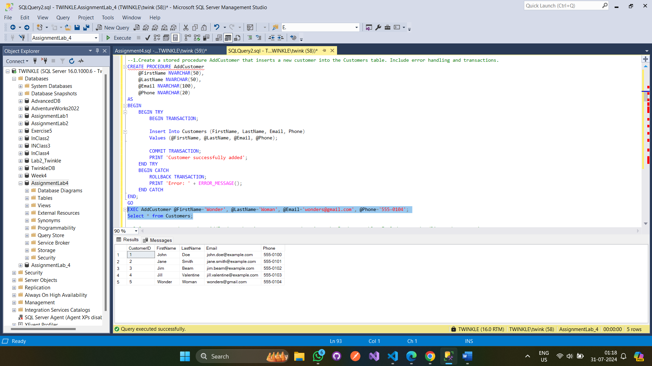

- Create a stored procedure AddProduct that inserts a new product into the Products table. Include error handling and transactions.
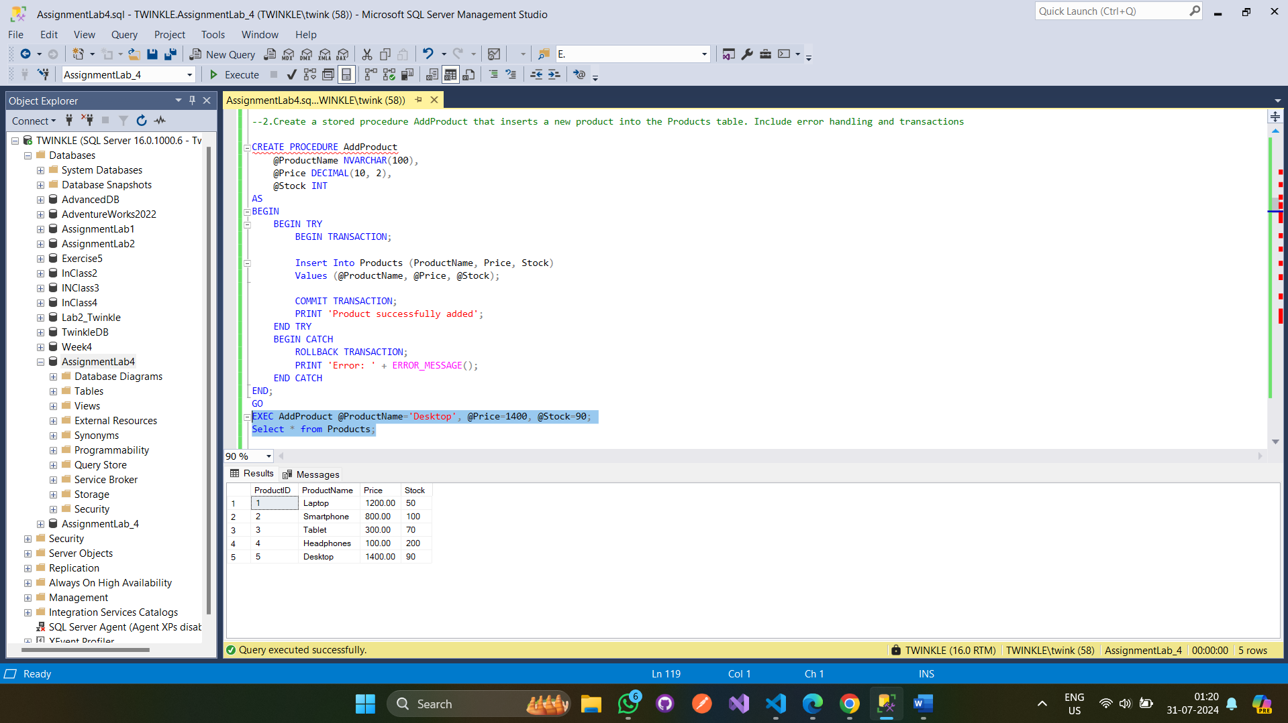

- Create a stored procedure CreateOrder that inserts a new order and its details into the Orders and OrderDetails tables, respectively. It should also update the product stock. Include error handling and transactions.
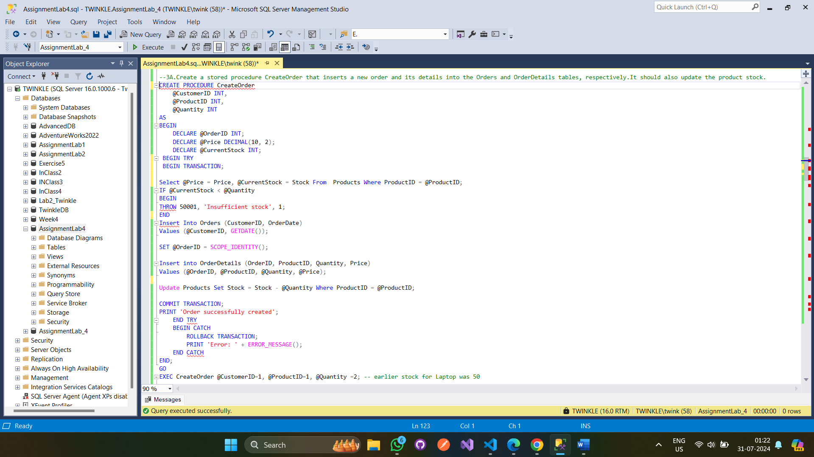
Output:
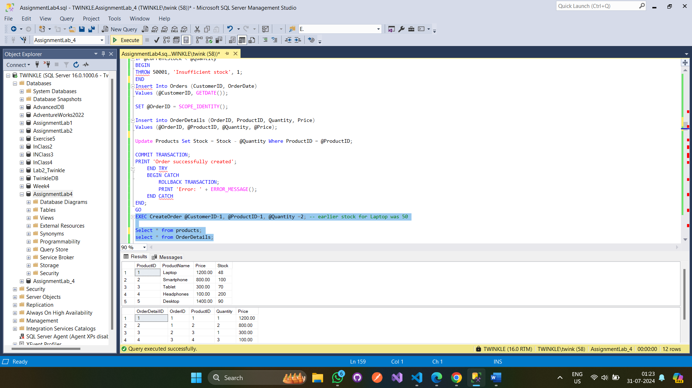

- Create a stored procedure UpdateCustomer that updates the details of an existing customer. Include error handling and transactions.
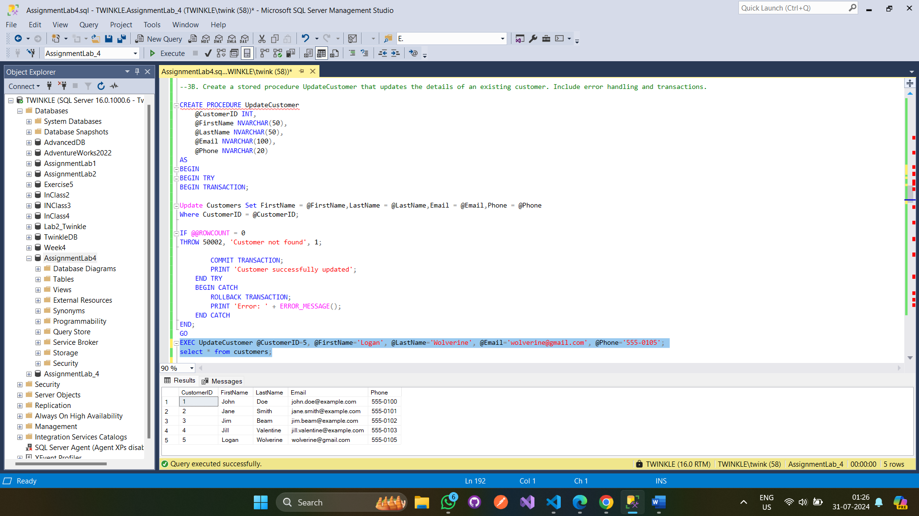

- Create a stored procedure DeleteCustomer that deletes a customer from the Customers table. Include error handling and transactions.
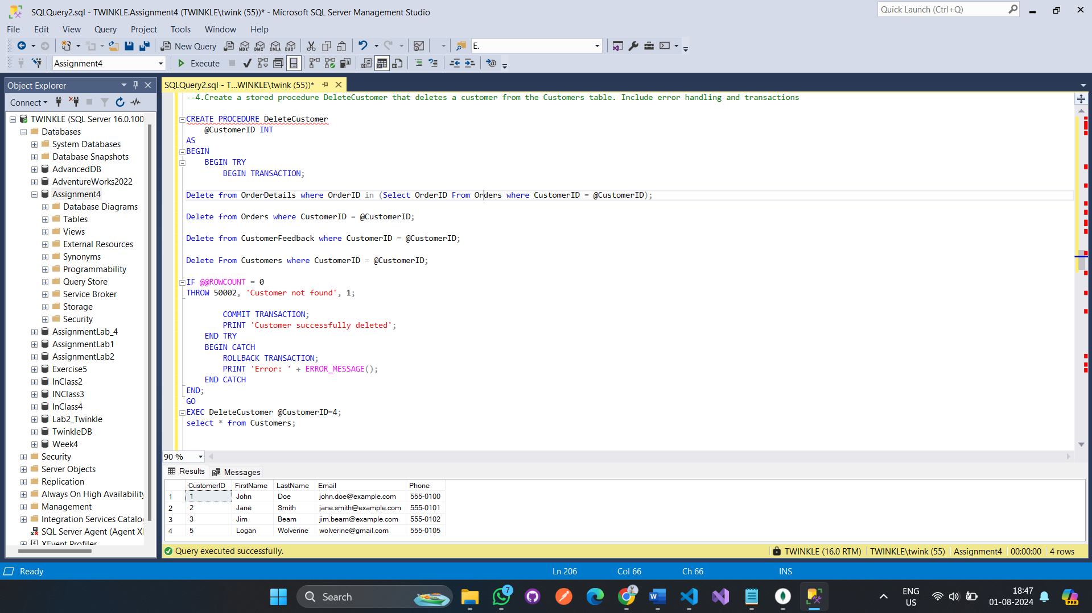

- Create a stored procedure UpdateProduct that updates the details of an existing product. Include error handling and transactions.
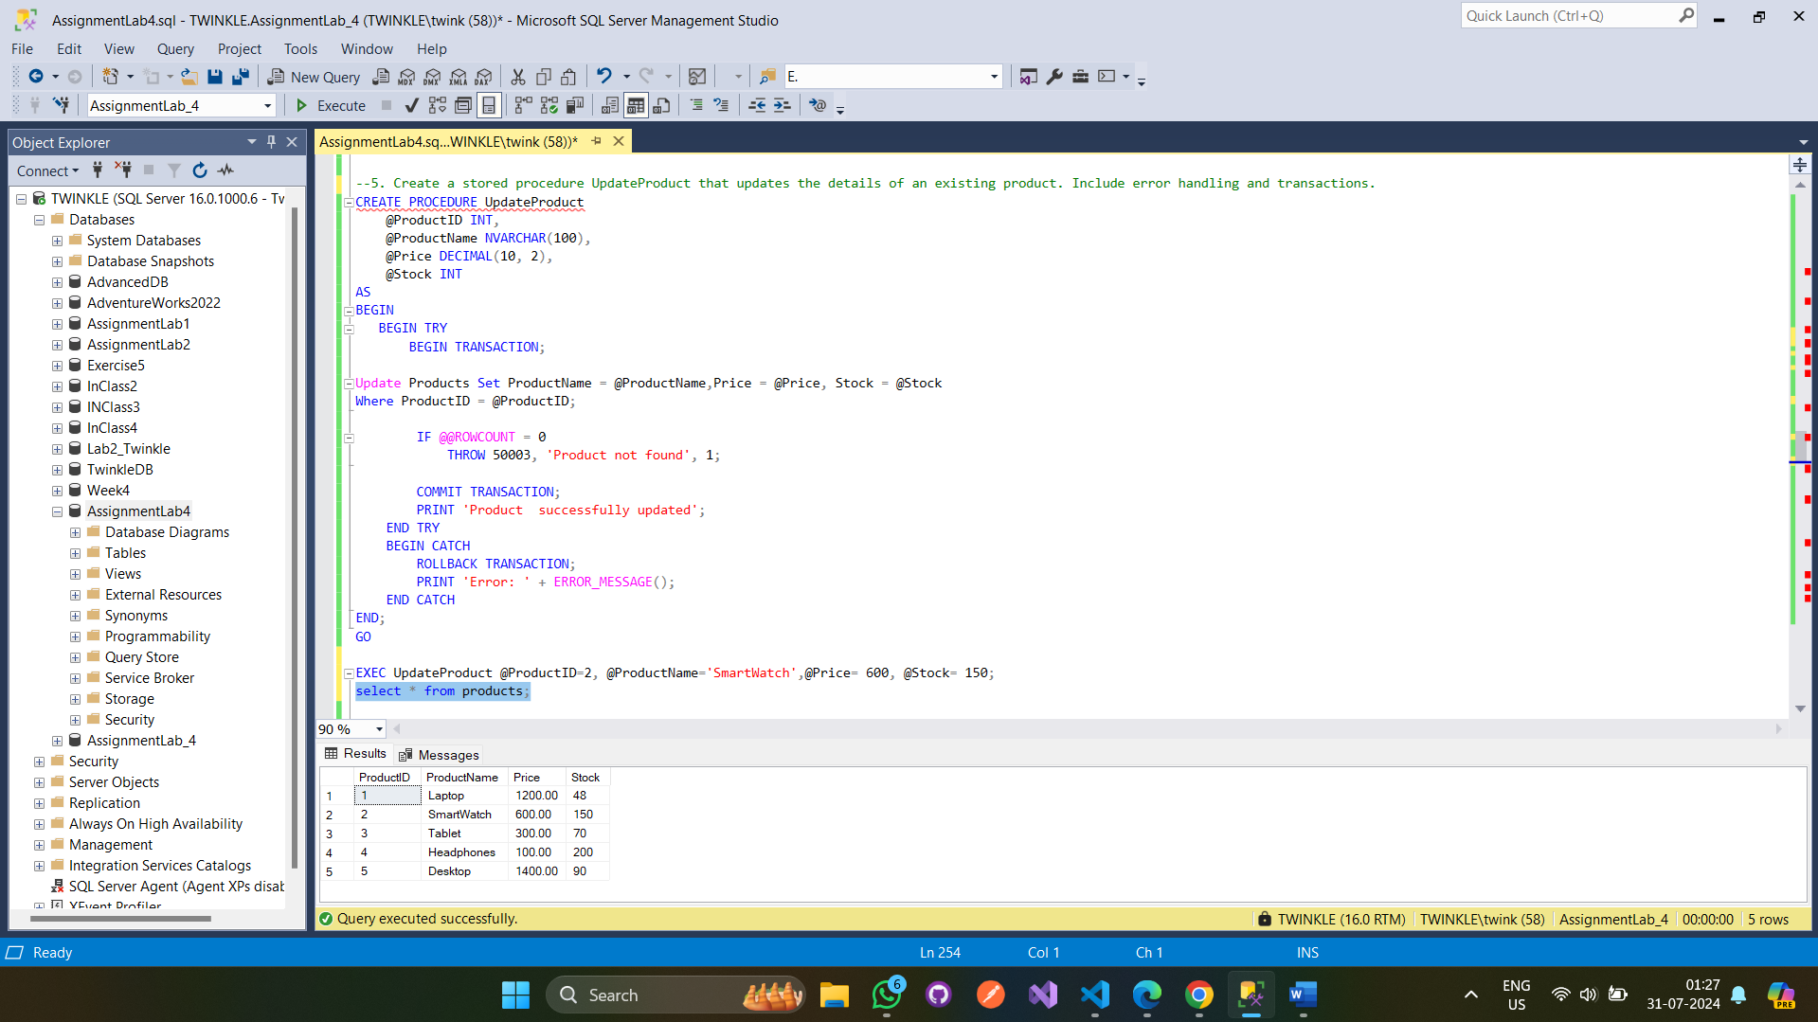

- Create a stored procedure DeleteProduct that deletes a product from the Products table. Include error handling and transactions.
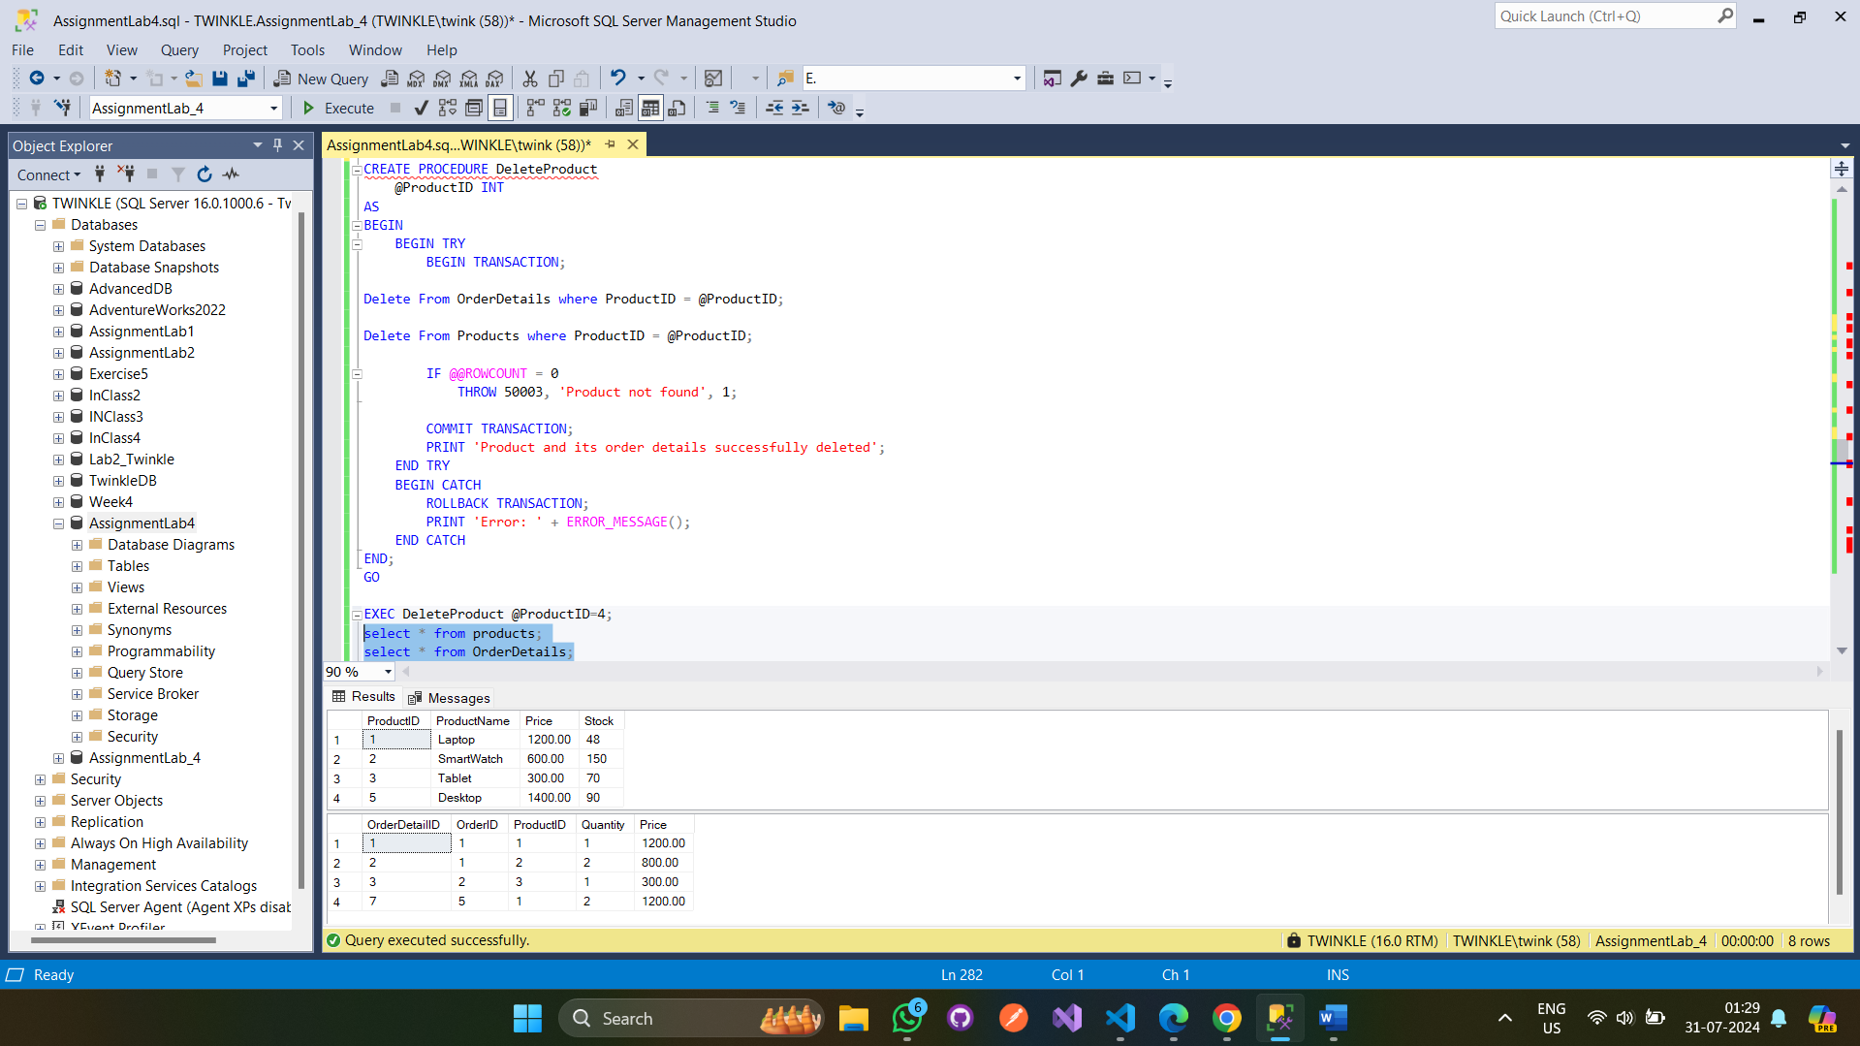

- Create a stored procedure ProcessReturn that processes a return of items by updating the OrderDetails and Products tables. Include error handling and transactions.
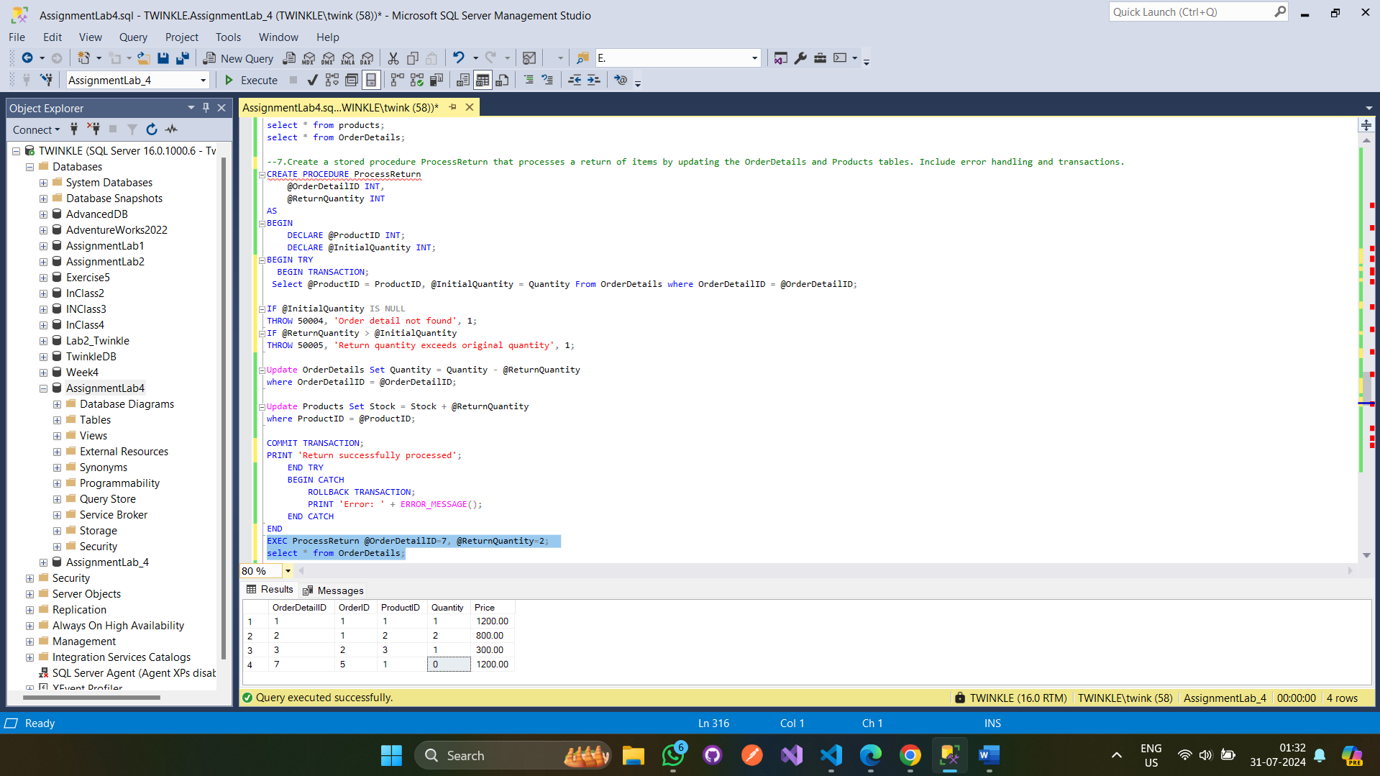

- Create a stored procedure GenerateSalesReport that generates a sales report for a given date range.
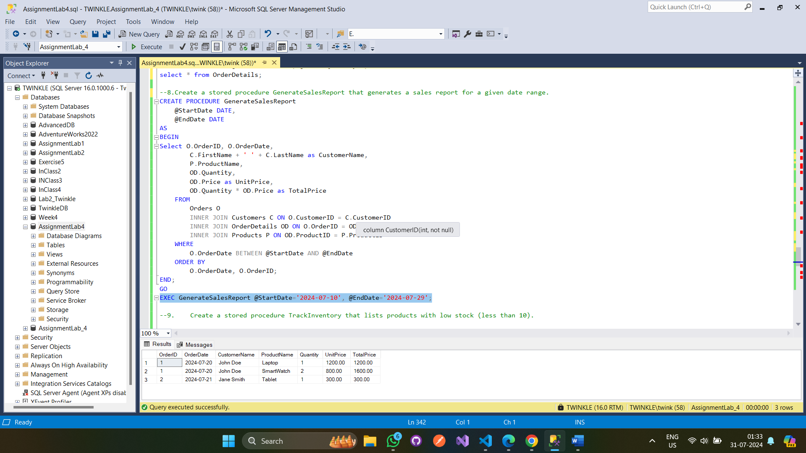

- Create a stored procedure TrackInventory that lists products with low stock (less than 10).
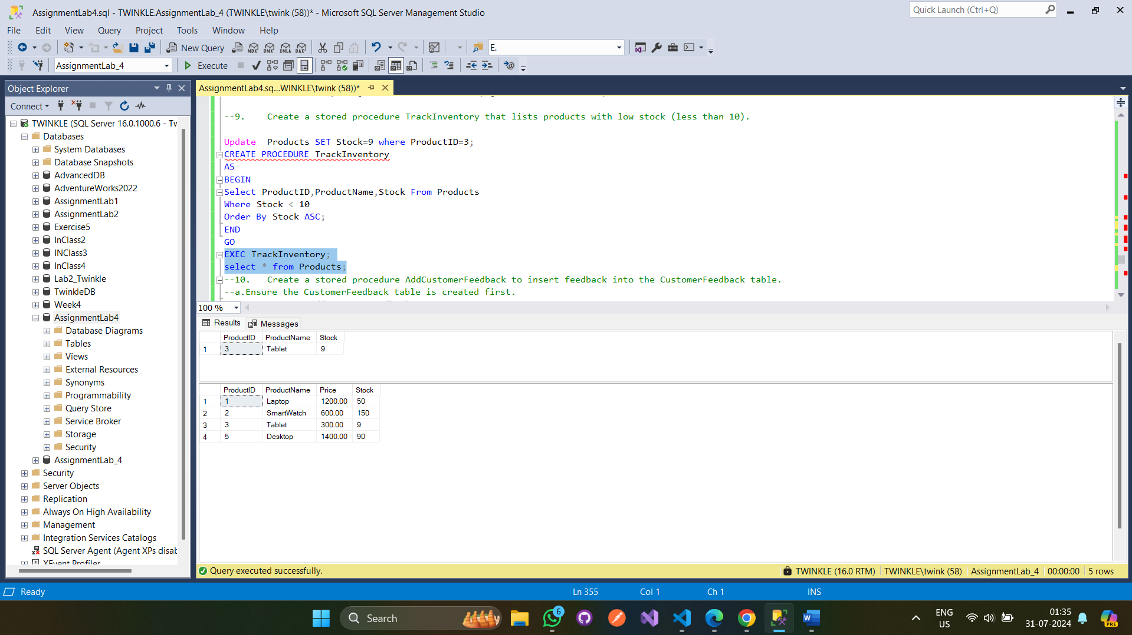

- Create a stored procedure AddCustomerFeedback to insert feedback into the
CustomerFeedback table. Ensure the CustomerFeedback table is created first.
